BYTEWISE LIMITED

Data Engineering Track

Task: Week – 1 (First Month)

Task No: 1

Task Date: 14-03-2023

Internee Name: Umer Farooq

Mentor Name: Ahtisham

# Task Details:

This task includes the following:

1. Big Data
2. Data Lake
3. Database
4. Data Warehouse

Each terminology will be briefly explained in document that is also available at [GitHub repository](https://github.com/Umer86/Data-Engineering-Tasks-Bytewise-Limited).

# BIG DATA:

* Big data refers to **extremely large and complex data sets** that are too big to be processed using traditional data processing tools and techniques.
* Big data can come from various sources such as:
  + social media,
  + sensors,
  + machines, and
  + other data-generating devices.
* Processing and analysing big data require specialized technologies such as Hadoop, Spark, and NoSQL databases.

**For example**, a healthcare provider might collect patient data from various sources, including electronic health records, wearables, and medical devices. Analysing this data using big data technologies can reveal patterns, trends, and insights that could improve patient outcomes, reduce costs, and enhance the overall quality of care.





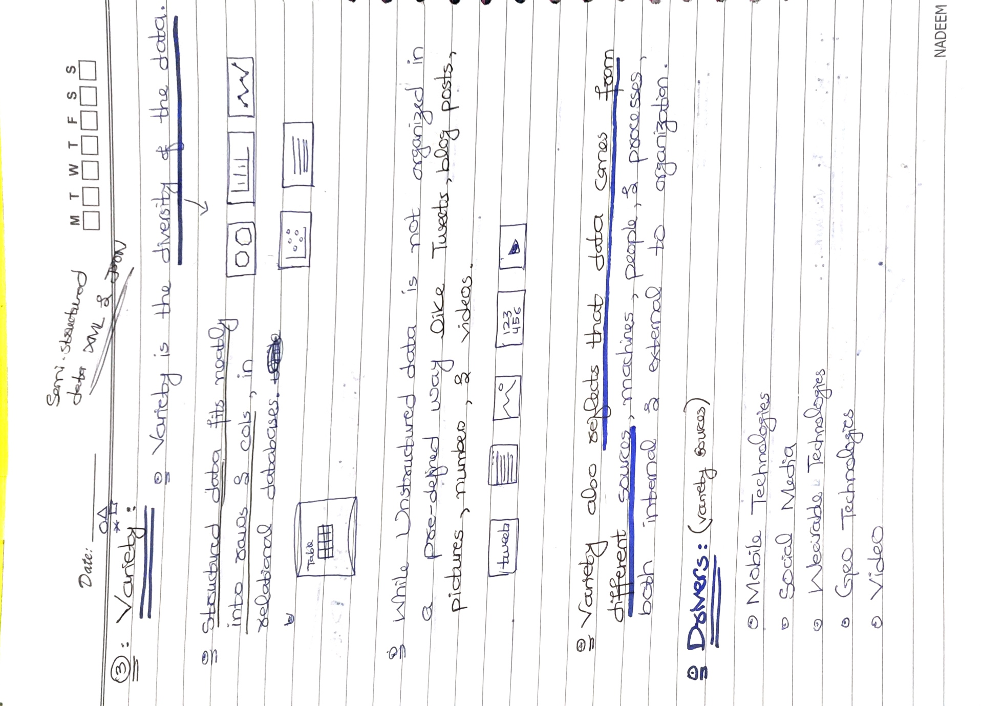

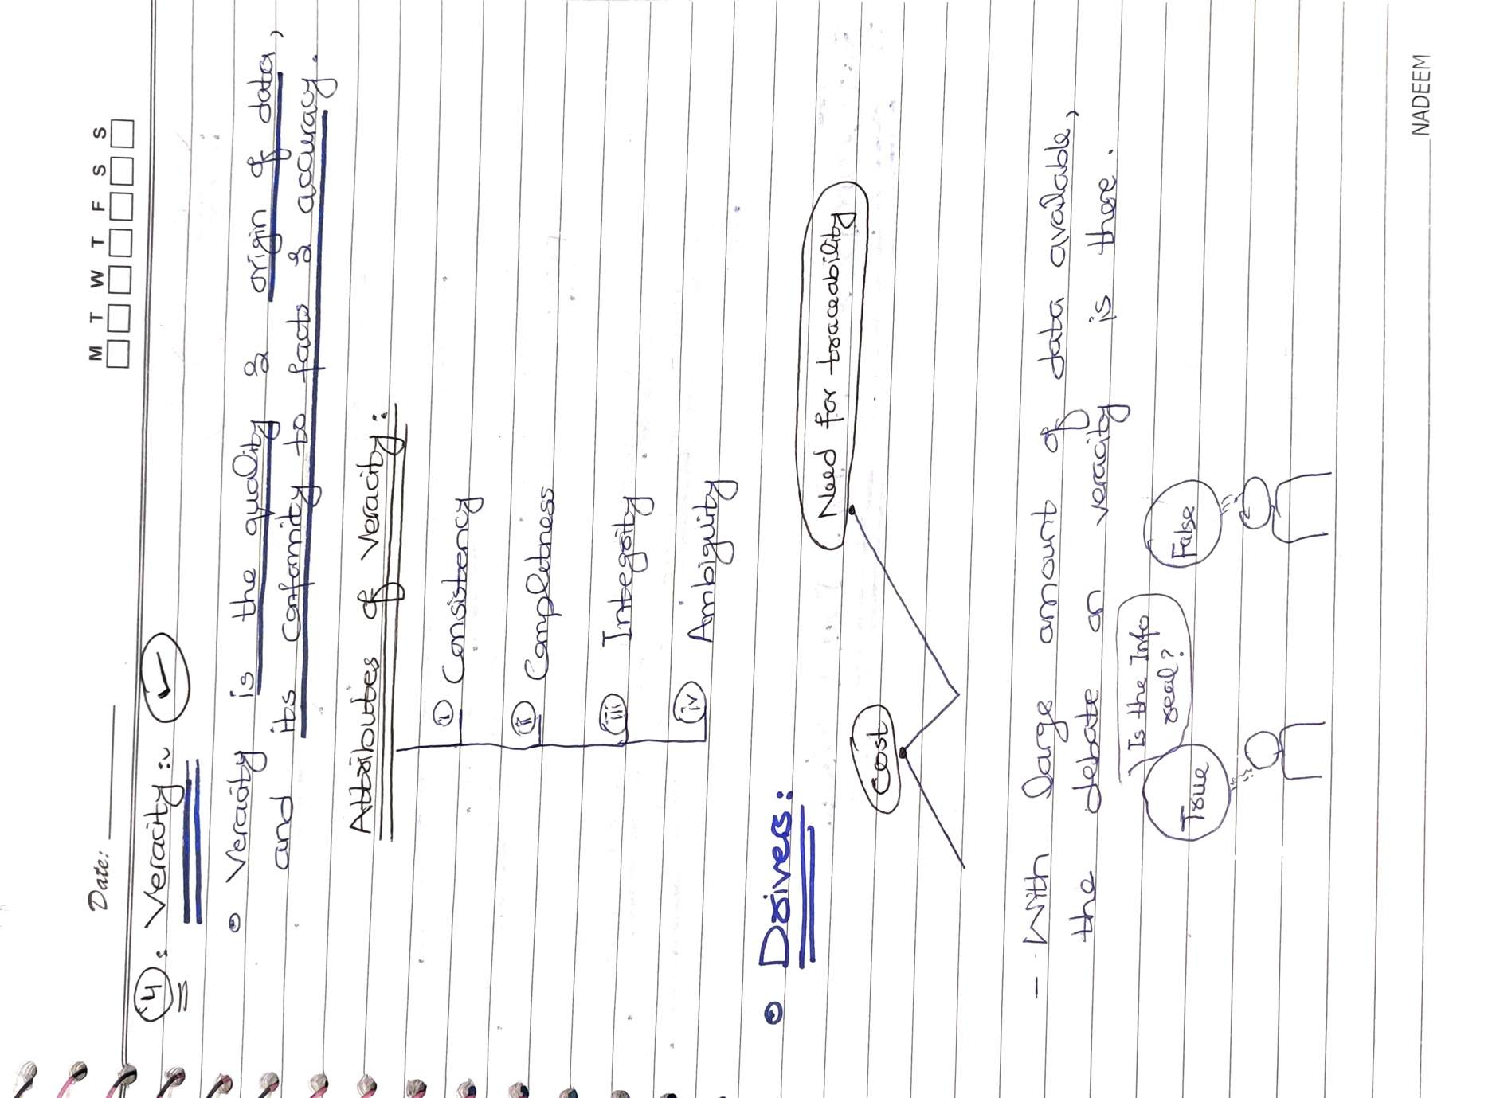





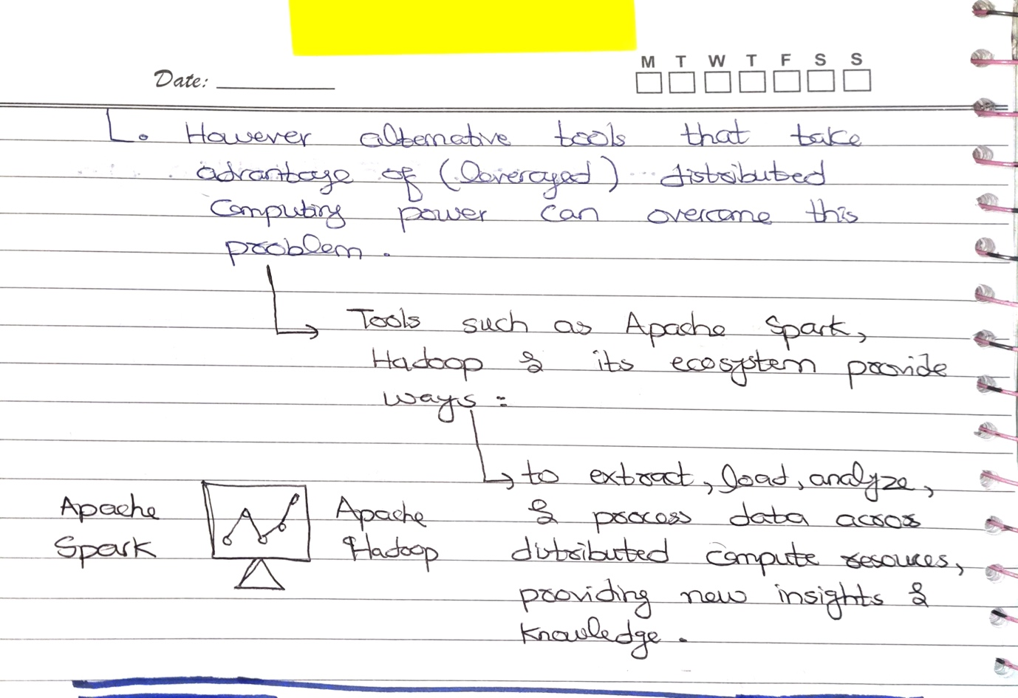

# DATA LAKE:

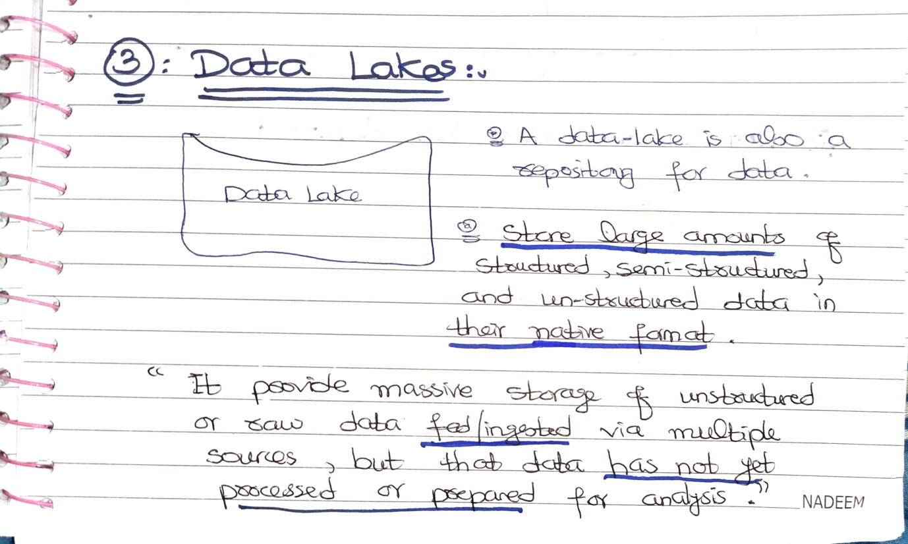



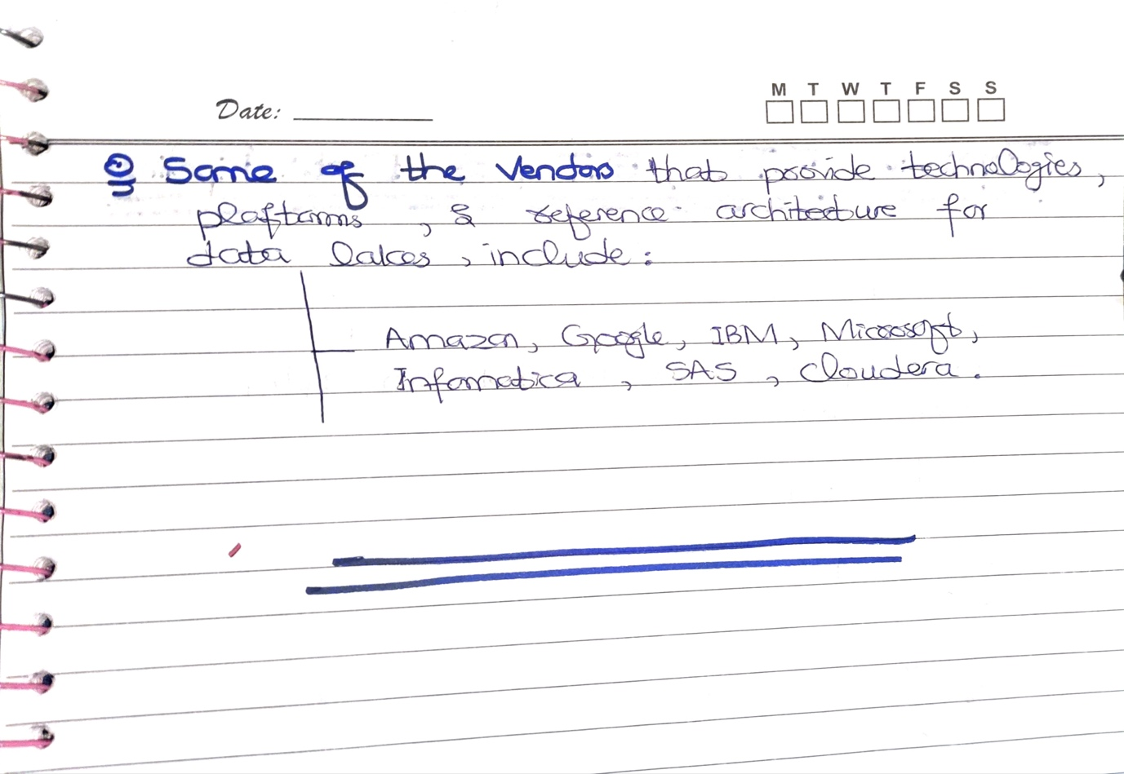

## Benefits of Data Lake:

1. Scalability: Data lakes can store vast amounts of data, making it easy to scale as your data needs grow.
2. Flexibility: Data lakes allow for the storage of raw, unprocessed data in its native format, making it easier to store and manage data from multiple sources.
3. Cost-Effective: Data lakes are typically less expensive than traditional data warehouses, as they use commodity hardware and open-source software.
4. Faster Data Processing: With data lakes, data can be processed in real-time, allowing for faster decision-making and better business outcomes.
5. Improved Analytics: Data lakes allow for the use of advanced analytics and machine learning algorithms to uncover insights that might otherwise be hidden in large and complex data sets.
6. Collaboration: Data lakes can be accessed by multiple users and teams, allowing for collaboration and the sharing of data and insights across the organization.

# DATABASE:

* Data repository is a general term used to refer to data that has been collected, organized, and isolated, so that it can be used for:
  + Business Operation, or
  + Mined for reporting & data analysis.
* It can be a small or large database infrastructure with one or more databases, that:
  + Collect,
  + Manage, &
  + Store data sets.
* So, there are different type of repositories, that may your data reside-in. It includes Databases.

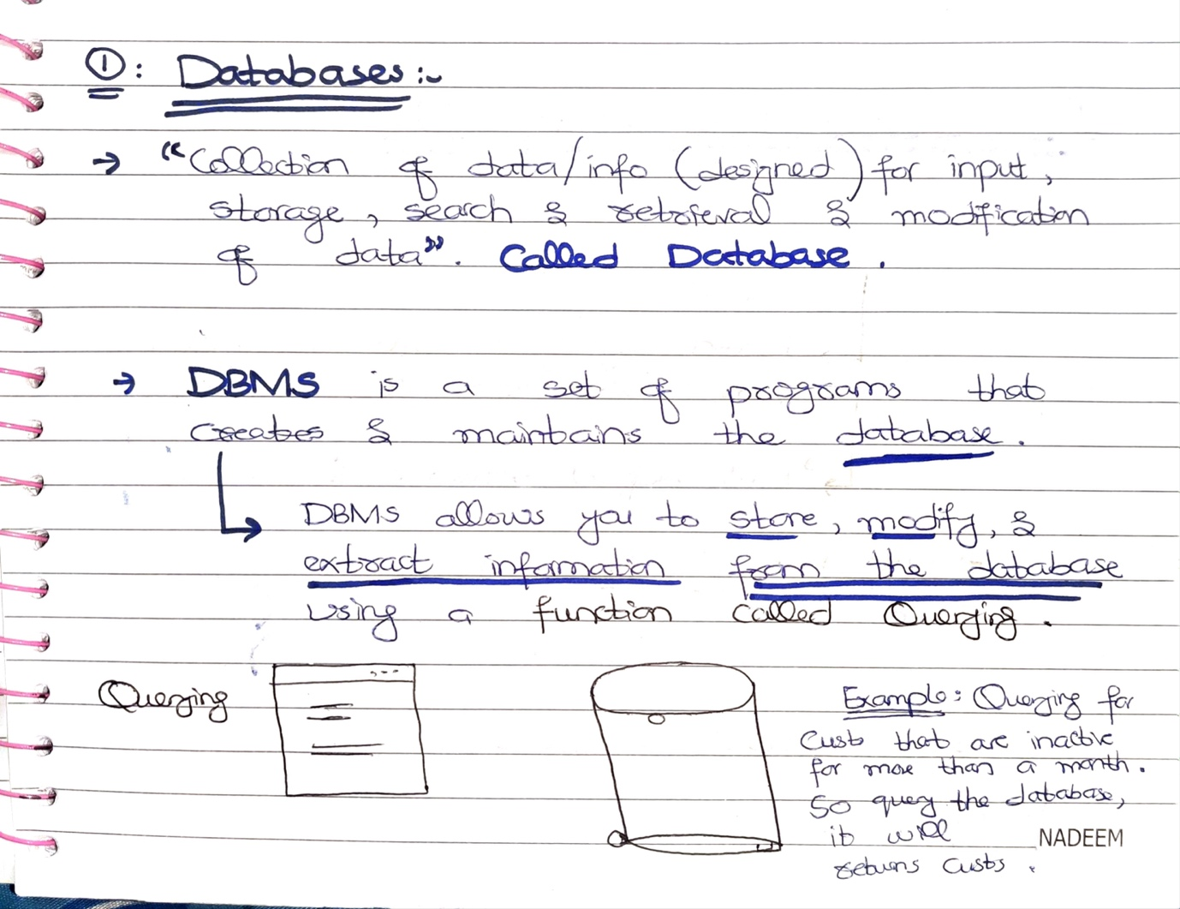

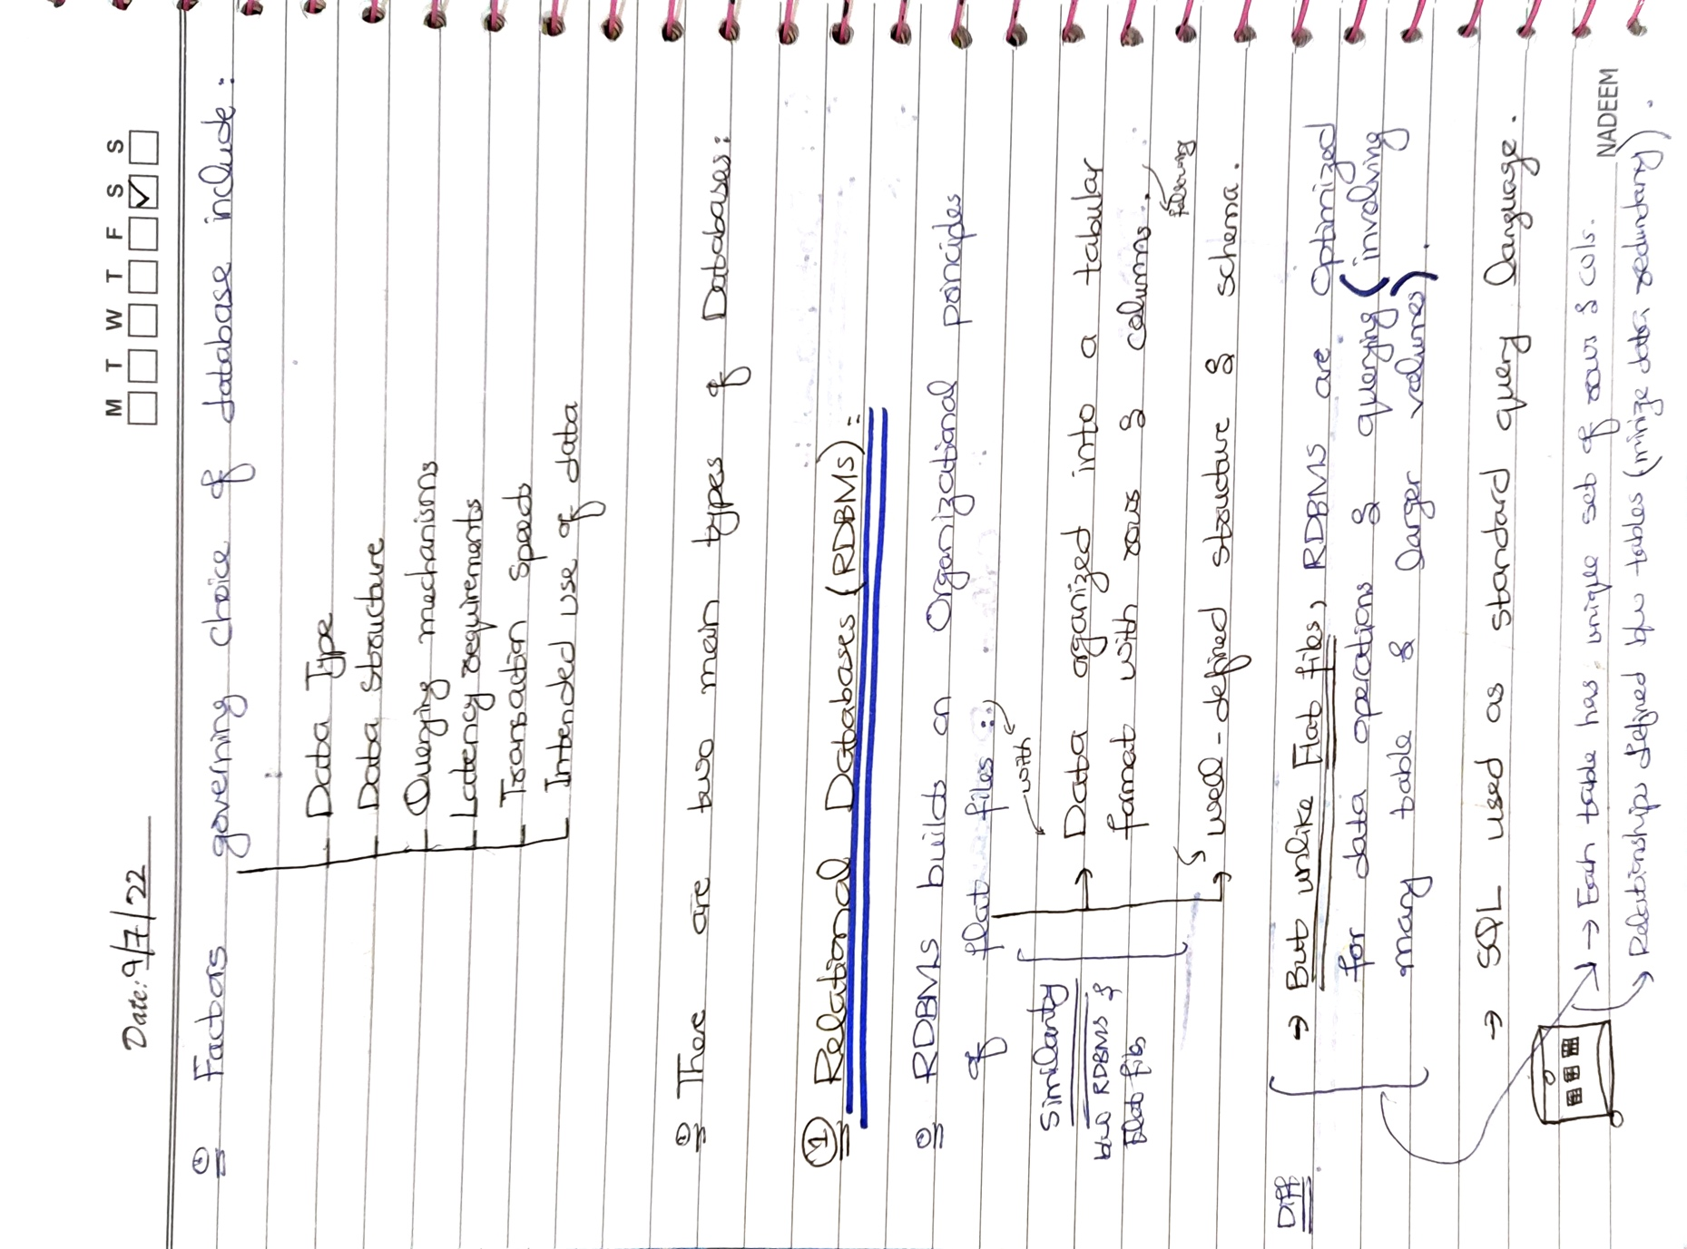

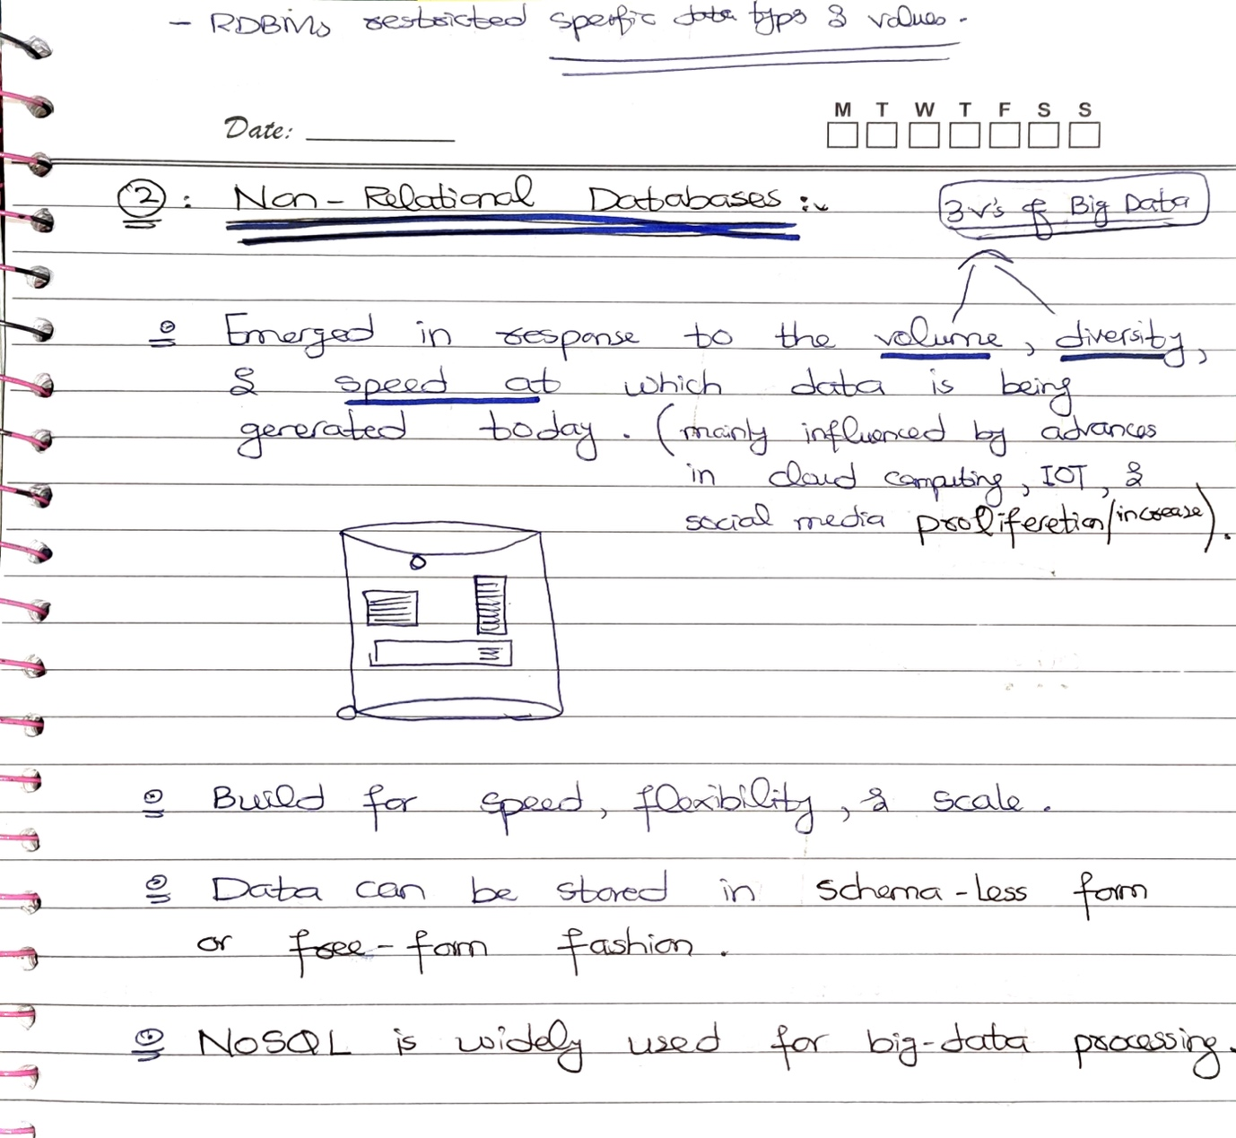

* This was short introduction of relational and non-relational databases. I have explained in details about the Relational and Non-Relational Databases below:

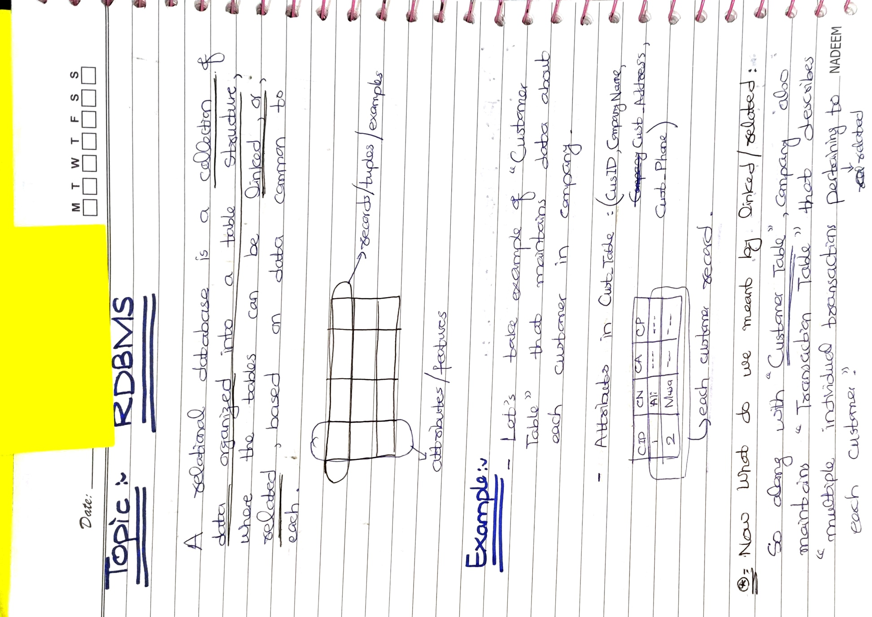



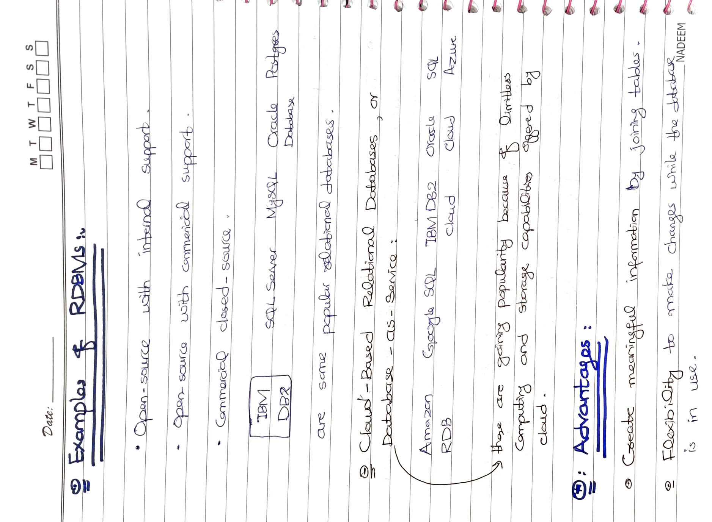







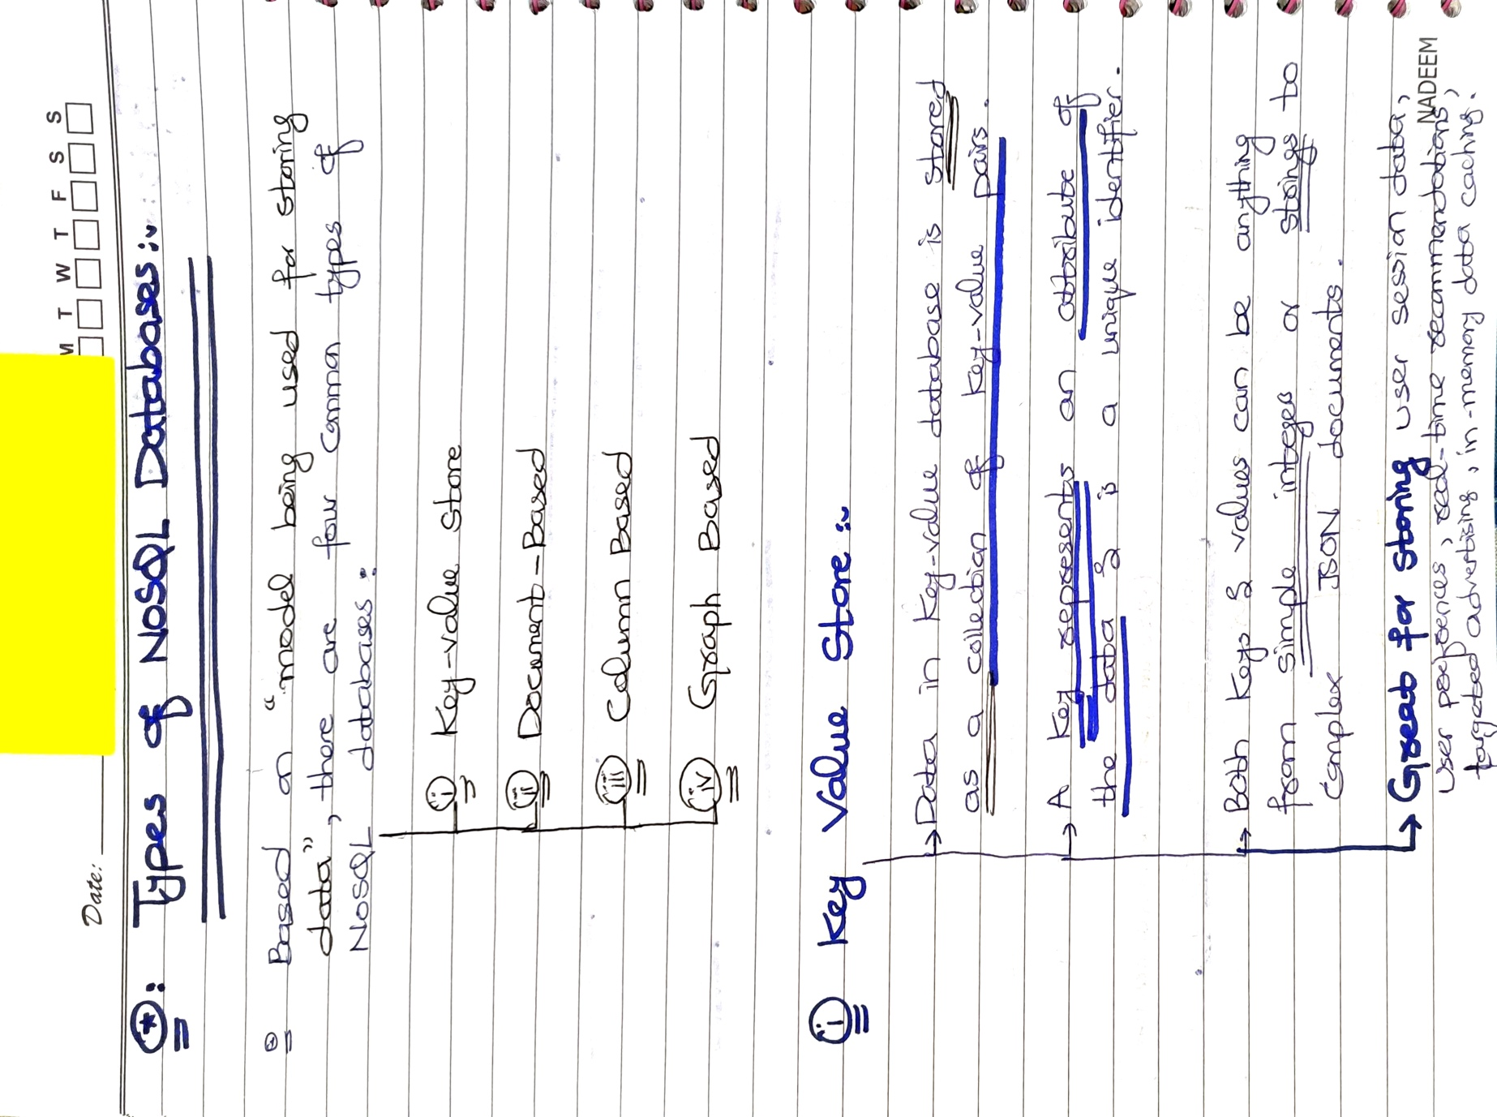

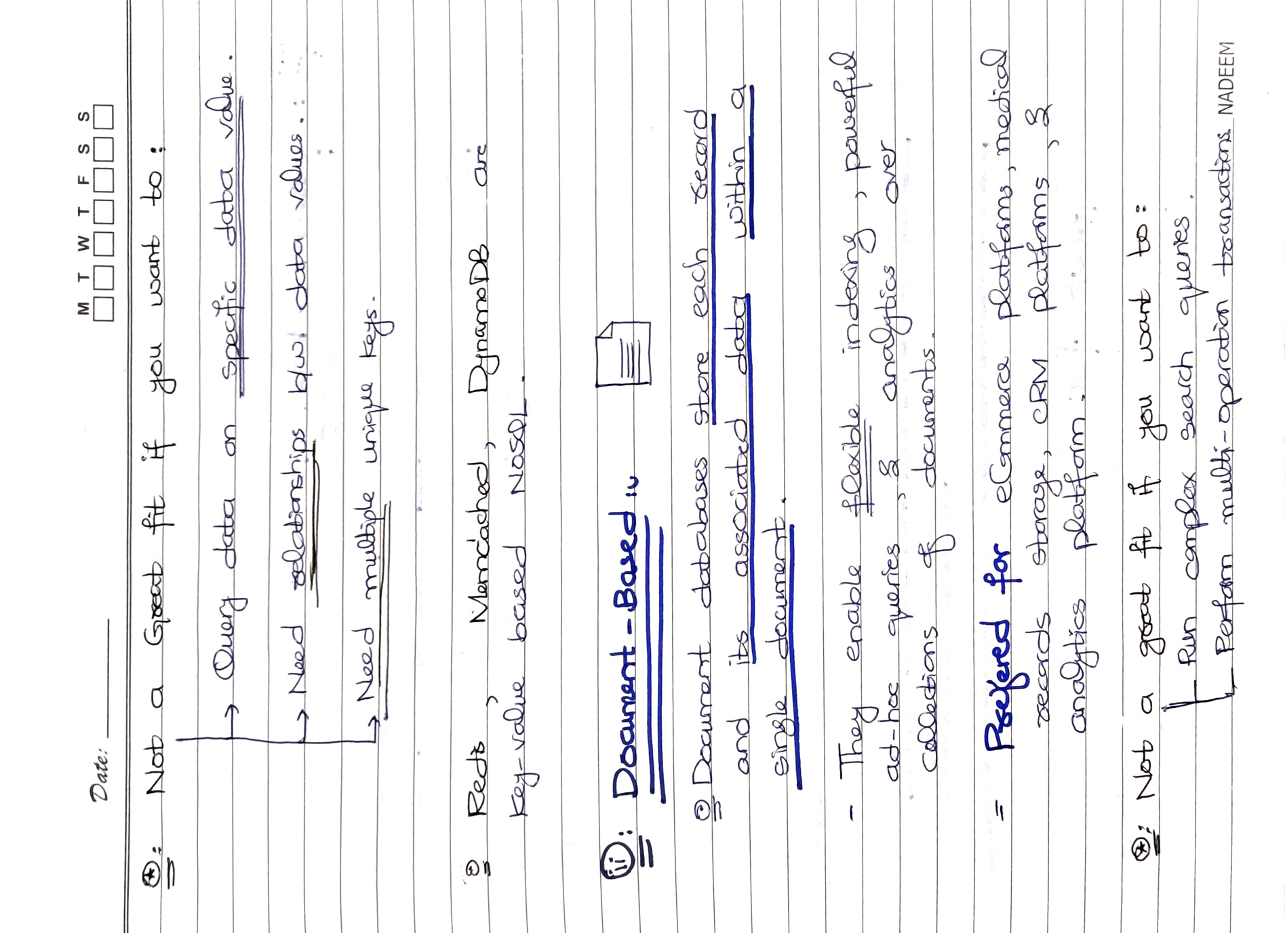



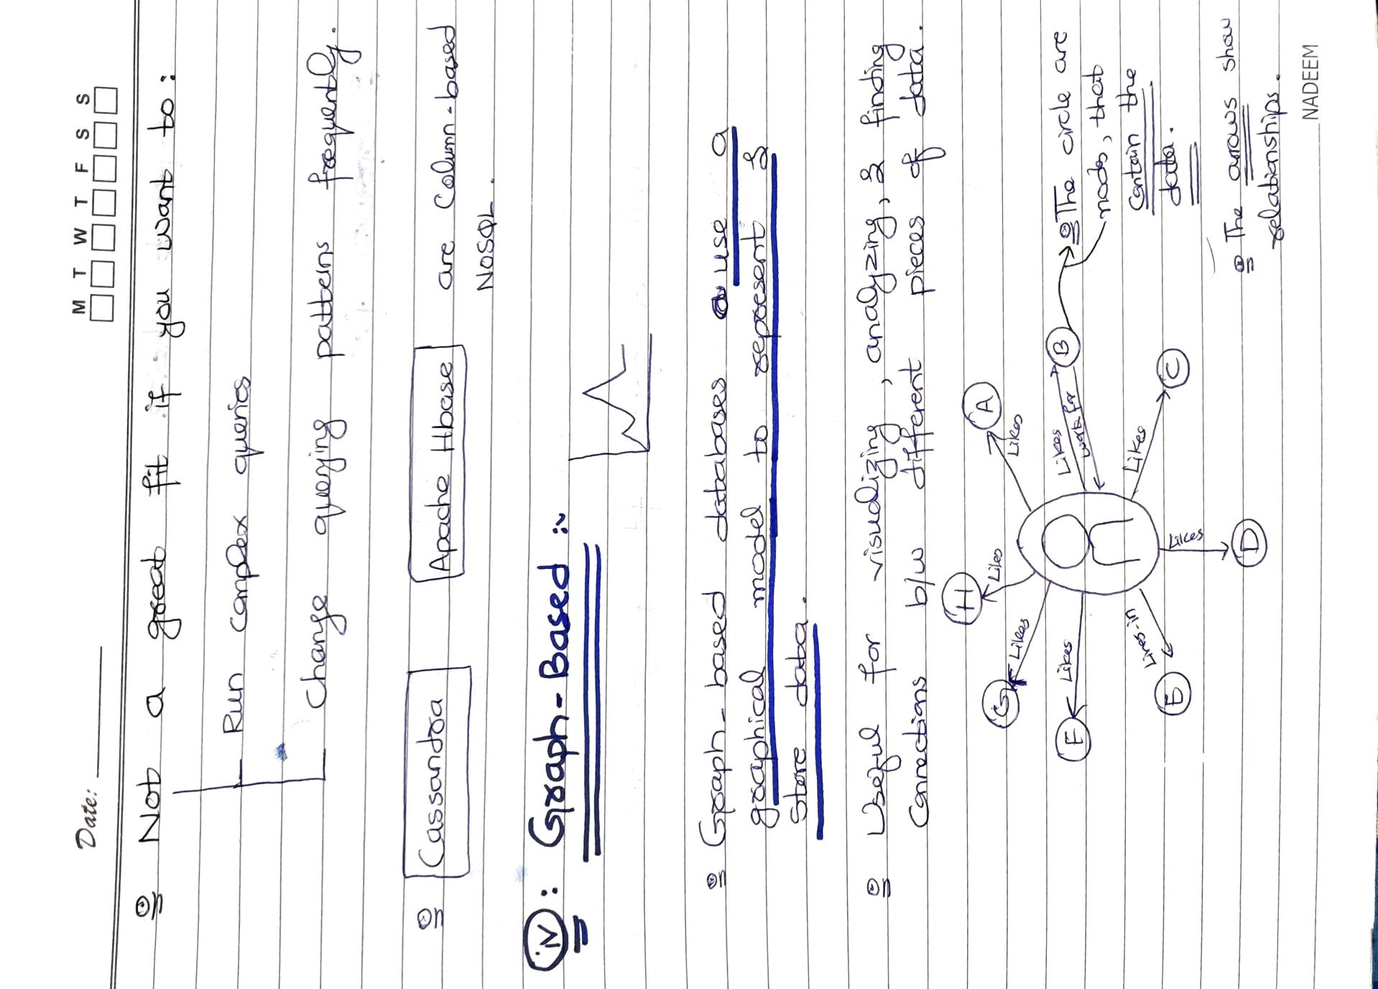

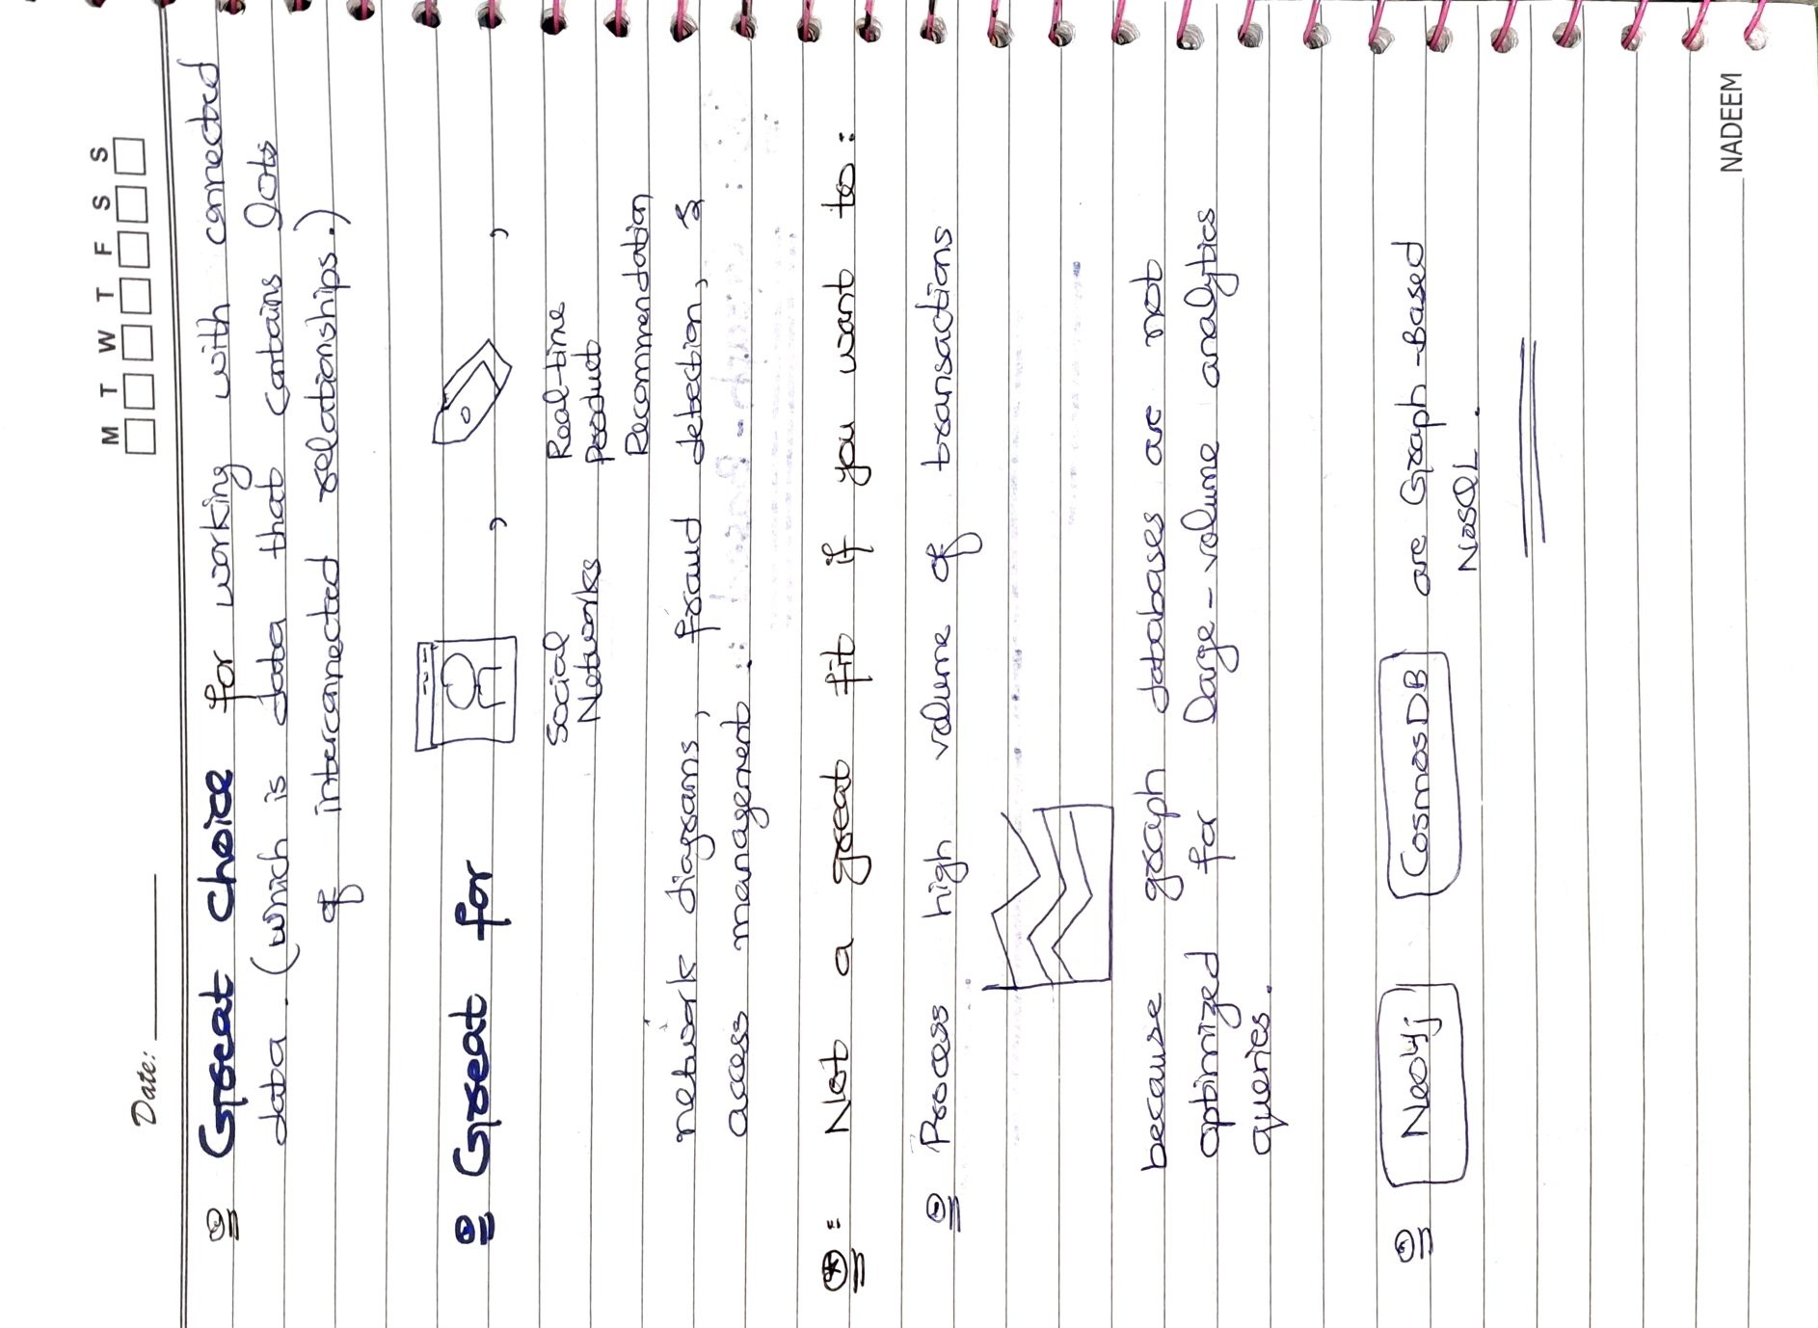



# DATA WAREHOUSE:

# 

* You may have read the last sentence of the above picture that we can use non-relational databases as Data Warehouse because of the emergence of Big Data and NOSQL data. **So yes, with the emergence of Big Data and NoSQL databases, non-relational data repositories have become popular for data warehousing**. Here are some examples of non-relational databases that can be used as data warehouses:
  + **Hadoop Distributed File System (HDFS):** HDFS is a distributed file system that is used to store large volumes of data across multiple nodes in a cluster. Hadoop also includes tools like MapReduce and Hive, which can be used to process and analyse data stored in HDFS.
  + **Apache Cassandra:** Cassandra is a highly scalable NoSQL database that is designed to handle large volumes of data across multiple data centres. It is often used for real-time data analysis and is popular in the finance, healthcare, and telecommunications industries.
  + **Amazon S3:** Amazon S3 is a cloud-based object storage service that is used to store and retrieve large amounts of data. It is often used as a data lake, where data from various sources is stored for later analysis.
  + **MongoDB:** MongoDB is a document-oriented NoSQL database that is designed to store and retrieve unstructured data. It is often used for real-time analytics and is popular in the gaming, healthcare, and media industries.
  + **Apache HBase:** HBase is a distributed, column-oriented NoSQL database that is designed to handle large volumes of sparse data. It is often used in combination with Hadoop for real-time data processing and analysis.

# 

# 